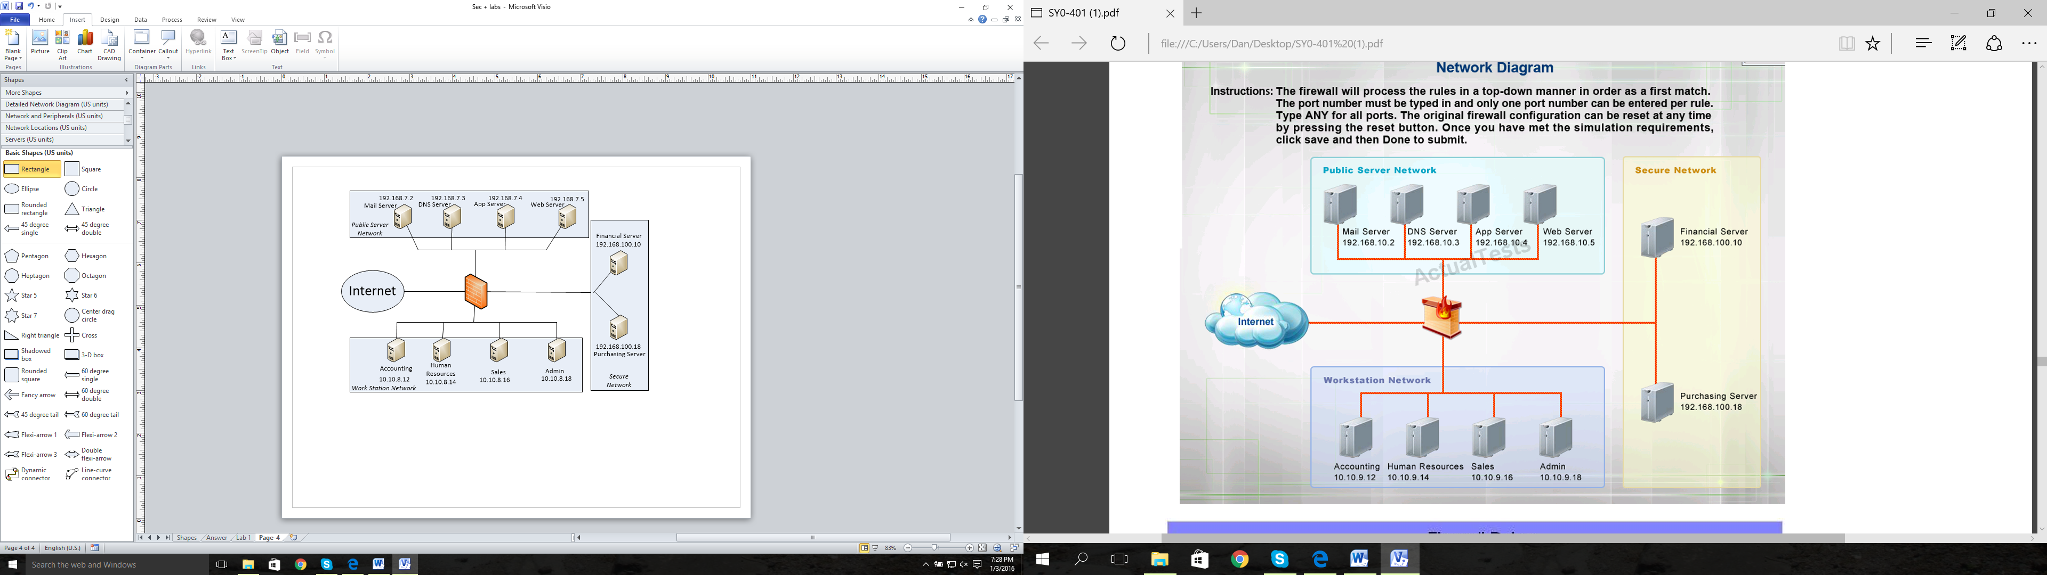

4

3

2

1

You are the head firewall technician for the Springfield Nuclear Power Plant and you are sitting down with your management personnel. You and your company are emplacing a new firewall on your network to maximize security and efficiency based on procedural goals at the last meeting. Follow the guidance below…

In one statement, prevent each Secure Network host from accessing the Public Server Network at 192.168.7.0 /28. (1 statement)  
Block people from the internet from presenting DNS requests on your network. (1 statement)  
Block Ping Traffic from entering the network from outside users. (1 statement)  
Block people from the Workstation Network from using unsecure web browsing with the Web Server . (1 statement)  
Allow people from the Workstation Network to access to the Mail Server via SMTP. (1 statement)  
Deny people from the workstation network from utilizing POP for the Mail Server on the network (1 statement)  
Prevent people from the public Server network (192.168.7.0 /29) from accessing the Financial Server and the Purchasing Server Individually. (2 statements)   
Deny all traffic from the Internet as the final statement. (1 statement) Place this in the LAST BOX; There should be two boxes above this box that were not used.

There are 9 total types of firewall statements you must create. Place them in order from top to bottom as depicted in the above tasking statements. Place the statement at the interface where it will prevent traffic from entering the firewall as no outbound port ACL are allowed in this scenario.

|  |  |  |  |  |  |
| --- | --- | --- | --- | --- | --- |
|  | Click below and select from the Scroll Menu | Click below and select from the Scroll Menu | ***Type Port if needed*** | ***Type TCP or UDP or ICMP or Any*** | ***Type Deny or Permit*** |
| ***Inbound*** | ***Source*** | ***Destination*** | ***Port*** | ***Protocol*** | ***Action*** |
| 3 | 192.168.100.0 /27 | 192.168.7.0 /28 |  | Any | Deny |
| 1 | ANY | ANY | 53 | Any | Deny |
| 1 | ANY | ANY |  | ICMP | Deny |
| 4 | 10.10.8.0 /27 | 192.168.7.5 | 80 | TCP | Deny |
| 4 | 10.10.8.0 /27 | 192.168.7.2 | 25 | TCP | Allow |
| 4 | 10.10.8.0 /27 | 192.168.7.2 | 110 | TCP | Deny |
| 2 | 192.168.7.0 /29 | 192.168.100.10 |  | Any | Deny |
| 2 | 192.168.7.0 /29 | 192.168.100.18 |  | Any | Deny |
| Choose an item. | Source | Destination |  |  |  |
| Choose an item. | Source | Destination |  |  |  |
| 1 | ANY | ANY |  | Any | Deny |